After completing this lab, you should be able to:
- Improve simulation performance by modifying Verilog code identified by VCS profiler utility as simulation bottlenecks
- Compile an existing Verilog design with the +rad compilation switch and execute the simulation binary to demonstrate an improvement in simulation performance

Fast RTL Verification


60 minutes
Unit 6
Learning Objectives
6

Getting Started
You will use the lossless codec for this lab:
You will improve the simulation performance at the RTL-level via two methods: changing the coding style and using VCS optimization switches.
This lab has two parts.
In Part A, you will use the +prof utility to locate simulation bottlenecks. You will then modify the Verilog code by changing the coding style to improve the simulation performance.
Here's a preview:
- Profile codec simulation with VCS profiler and record CPU run time
- Modify codec Verilog code segment identified as bottleneck
- Re-simulate and record CPU run time
- Repeat the first three steps until simulation speed is acceptable
In Part B, you will use the +rad VCS optimization switches to improve simulation performance.
Here's a preview:
- Simulate codec design and record CPU run time
- Compile & simulate codec with +rad switch and record CPU run time

Figure 6-1: Flow Diagram of Lab Exercise
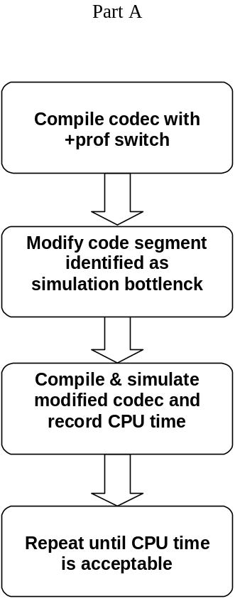
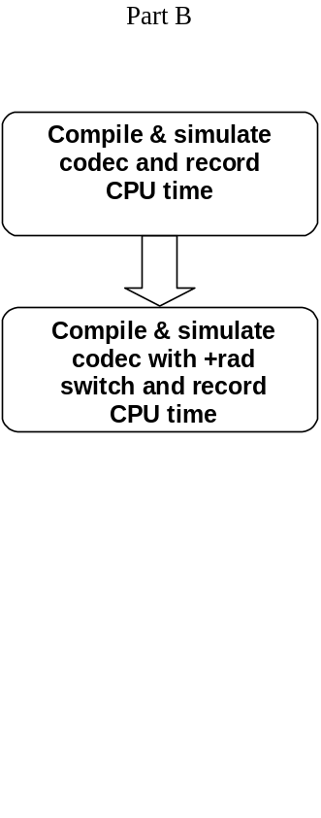

Part A: Using VCS profiler
- Record codec Simulation CPU Time
Go into the lab6 directory.
- shell> cd ./lab6/parta
Compile and simulate the codec design without any optimization.
- shell> vcs –f codec.f CAM.v fileio.o –R
- Record CPU time & Data structure size
CPU time:
Data structure size:
For an input stimulus file of 323 bytes, this simulation time seems too long. Let’s improve this simulation time.
- Profile Simulation CPU Time with +prof
First, run the profiling utility to see how simulation time is being spent.
- shell> vcs –f codec.f CAM.v fileio.o –R +prof
- Evaluate codec Simulation Performance
Once the simulation run completes, examine the vcs.prof file.
- Open vcs.prof with an editor
In Top Level View, the design uses greater than 90% of the CPU run time. This is good, you want simulation executing design operations rather than overhead.

================================================================================
TOP LEVEL VIEW
================================================================================
TYPE %Totaltime
--------------------------------------------------------------------------------
DPI 0.00
PLI 0.00
VCD 0.00
KERNEL 0.00
MODULES 100.00
PROGRAMS 0.00
PROGRAM GC 0.00
--------------------------------------------------------------------------------
In Module View, the cam module requires most of the simulation time. This may or may not be a problem. Since this codec relies heavily on processing data in the cam module but it is an area to watch out for.
===========================================================================
MODULE VIEW
===========================================================================
Module(index) %Totaltime No of Instances Definition
---------------------------------------------------------------------------
cam (1) 98.67 2 CAM.v:5.
Addr_gen (2) 1.14 2 codec.v:347
In the Module to Construct Mapping, we start to see something a little more out of wack. The simulation time within the cam module is spent in the always block at lines 80-83 of the CAM.v source code. This could be a problem.

===========================================================================
MODULE TO CONSTRUCT MAPPING
===========================================================================

___________________________________________________________________________
1. cam
---------------------------------------------------------------------------
Construct type %Totaltime %Moduletime LineNo
---------------------------------------------------------------------------
Always 40.80 41.35 CAM.v : 80-83.
Always 32.26 32.69 CAM.v : 36-61.
Always 12.33 12.50 CAM.v : 90-92.
Always 11.95 12.12 CAM.v : 86-88.
Always 0.76 0.77 CAM.v : 66-76.
Combinational 0.57 0.58 CAM.v : 5, 31, 33.

Please take a look at lines 80-83 of the CAM.v source code.
- Open CAM.v with an editor and locate line 80
Here’s what this section of the code looks like:
always @(din or match_search or match3_dly or
bit0 or bit1 or bit2 or bit3 or bit4 or bit5 or bit6 or bit7)
for (l = 0; l <= 4095; l = l+1)
match1[l] = ((match3_dly[l] | match_search) & (din == {bit7[l], bit6[l],
bit5[l], bit4[l], bit3[l], bit2[l], bit1[l], bit0[l]}));
This looping structure is not efficient.
- Modify CAM.v module and Save as CAM1.v
- Substitute the always block with the following:
assign match1 = (match3_dly | {4096 {match_search} }) &
(({4096 {din[0]} } ~^ bit0) & ({4096 {din[1]} } ~^ bit1) &
({4096 {din[2]} } ~^ bit2) & ({4096 {din[3]} } ~^ bit3) &
({4096 {din[4]} } ~^ bit4) & ({4096 {din[5]} } ~^ bit5) &
({4096 {din[6]} } ~^ bit6) & ({4096 {din[7]} } ~^ bit7));
You will also need to change the match1 from reg type to wire.
- Make the changes and save to “CAM1.v”
- Compile & Simulate to Record CPU Time
Compile & simulate the codec design with the modified cam module.
- shell> vcs –f codec.f CAM1.v fileio.o –R
- Record CPU time & Data structure size
CPU time:
Data structure size:
The simulation run time improved but not significantly. The bottleneck may have just move from one area to another. Please continue to look for the bottlenecks.
- Profile codec Simulation Performance
Run the profiling utility again to see how simulation time is being spent.
- shell> vcs –f codec.f CAM1.v fileio.o –R +prof
- Evaluate codec Simulation Performance
Once the simulation run completes, examine the vcs.prof file.
- Open vcs.prof with an editor
In the Module to Construct Mapping, the simulation time in the cam module is now primarily spent in the always block, line 37-62 of the CAM1.v source code.

===========================================================================
MODULE TO CONSTRUCT MAPPING
===========================================================================
__________________________________________________________________________
1. cam
---------------------------------------------------------------------------
Construct type %Totaltime %Moduletime LineNo
---------------------------------------------------------------------------
Always 52.37 54.79 CAM1.v : 38-63.
Always 19.56 20.46 CAM1.v : 100-102.
Always 17.67 18.48 CAM1.v : 96-98.
Combinational 5.36 5.61 CAM1.v : 5, 33, 35, 90.
Always 0.63 0.66 CAM1.v : 68-78.

- Open CAM1.v with an editor and locate line 38
Here’s what this section of the code looks like:
always @(posedge clk or negedge rstN)
begin
if (!rstN) begin
bit0 <= 0; bit1 <= 0; bit2 <= 0; bit3 <= 0;
bit4 <= 0; bit5 <= 0; bit6 <= 0; bit7 <= 0;
end
else if (!ldN) begin
bit0[0] <= din[0];
bit1[0] <= din[1];
bit2[0] <= din[2];
bit3[0] <= din[3];
bit4[0] <= din[4];
bit5[0] <= din[5];
bit6[0] <= din[6];
bit7[0] <= din[7];
for (i = 1; i <= 4095; i = i+1) begin
bit0[i] <= bit0[i-1];
bit1[i] <= bit1[i-1];
bit2[i] <= bit2[i-1];
bit3[i] <= bit3[i-1];
bit4[i] <= bit4[i-1];
bit5[i] <= bit5[i-1];
bit6[i] <= bit6[i-1];
bit7[i] <= bit7[i-1];
end
end
end
Examine this code closely, you will notice that this is really just a shift operation.

Modify CAM1.v module and Save as CAM2.v
Please recode the cam module as follows:
always @(posedge clk or negedge rstN)
begin
if (!rstN) begin
bit0 <= 0; bit1 <= 0; bit2 <= 0; bit3 <= 0;
bit4 <= 0; bit5 <= 0; bit6 <= 0; bit7 <= 0;
end
else if (!ldN) begin
bit0 <= {bit0[4094:0], din[0]};
bit1 <= {bit1[4094:0], din[1]};
bit2 <= {bit2[4094:0], din[2]};
bit3 <= {bit3[4094:0], din[3]};
bit4 <= {bit4[4094:0], din[4]};
bit5 <= {bit5[4094:0], din[5]};
bit6 <= {bit6[4094:0], din[6]};
bit7 <= {bit7[4094:0], din[7]};
end
end
- Make the changes and save to “CAM2.v”
- Compile & Simulate to Record CPU Time
Compile and simulate codec with CAM2.v.
- shell> vcs –f codec.f CAM2.v fileio.o –R
- Record CPU time & Data structure size
CPU time:
Data structure size:
The simulation run time has decreased significantly.

Profile codec Simulation Performance
Please take one last look at the profile report.
- shell> vcs –f codec.f CAM2.v fileio.o –R +prof
- Open vcs.prof file with editor
The simulation time is now dominated by two always blocks.
We have increased the performance sufficiently for now. Move on and try the effects of the optimization switches.

Part B: Using VCS Optimization Switches
- Record codec Simulation CPU Time
Go into the lab5 partb directory.
- shell> cd ../partb
In this lab, we have reproduced the CAM2.v module and included it in the codec.f file. We also made the input stimulus file test larger. It is now seven times the size that was used in part A. Theoretically, this should simulate seven times slower. As you shall see, with the aid of performance options in VCS, the exact opposite is true. We will be able to run simulation at a much higher speed.
Please record the simulation time without optimization switches.
- shell> vcs –f codec.f fileio.o –R
- Record CPU time & Data structure size
CPU time:
Data structure size:
This simulation took a significant amount of time to complete. In the following steps you will improve this situation time.
- Simulate with +rad Optimization
Try using the +rad optimization switch.
- shell> vcs –f codec.f fileio.o –R +rad
- Record CPU time & Data structure size
CPU time:
Data structure size:
This is quite a difference in CPU time. The improvement in simulation speed depends heavily on your coding style and design complexity. Your own designs will experience a different speed up result.

